DAY 4 – TEST EXECUTION & DEFECT FLOW
Test Execution Lifecycle: Create Test Execution, add tests manually and Test Sets
Executing Tests: Pass, Fail, Blocked, execution best practices
Evidence Management: Screenshots, logs, evidence standards
Defect Flow: Create bugs, link defects, retesting, execution history

Test Execution Lifecycle: Create Test Execution, add tests manually and Test Sets ::
The test execution lifecycle defines how tests move from planning to completion.
Key Stages:
- Creation of Test Execution issue
- Adding tests to execution
- Executing tests
- Recording results
- Managing defects
- Re-execution after fixes
Each Test Execution represents a specific execution cycle, such as sprint testing, regression testing, or release validation.
Creating a Test Execution Issue :
A Test Execution issue is used to execute one or more Test issues. Steps to Create a Test Execution:
- Select issue type as Test Execution
- Provide summary and description
- Assign to appropriate tester
Test Executions can be created for specific sprints, builds, or environments.
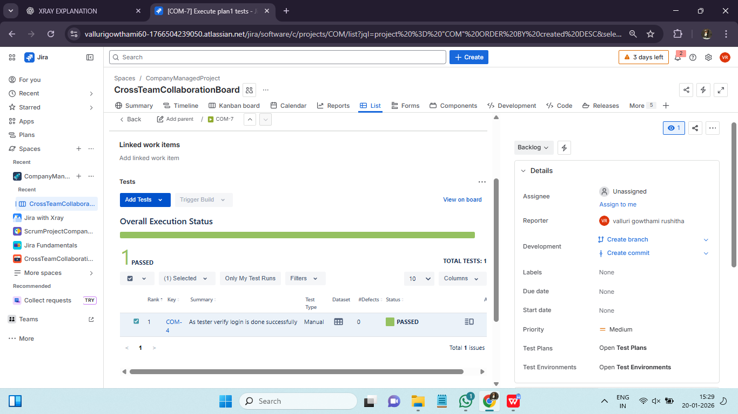
Adding Tests to Test Execution :
Tests can be added to a Test Execution in multiple ways:
- Manually adding individual Test issues
- Adding all tests from a Test Set
- Adding tests linked to a Test Plan
This flexibility allows teams to quickly prepare executions based on testing needs.
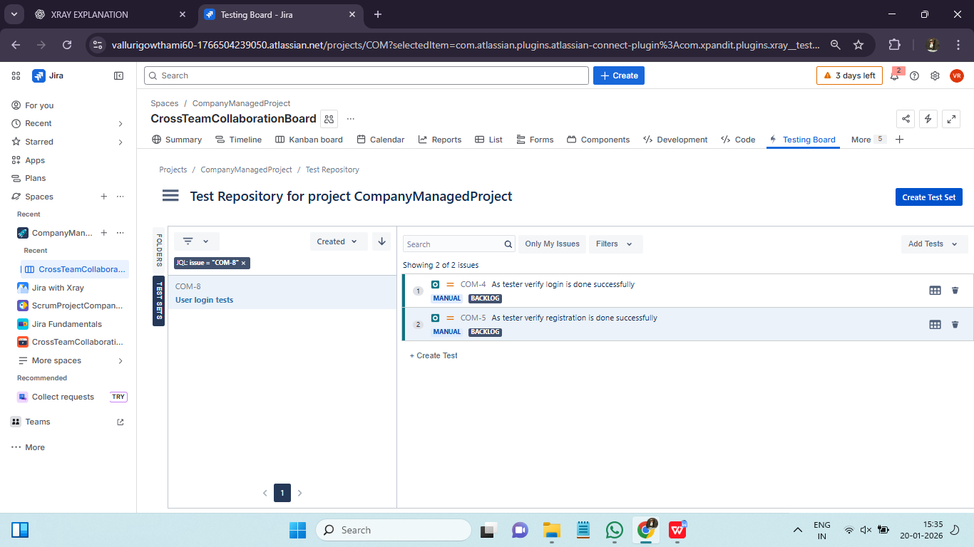

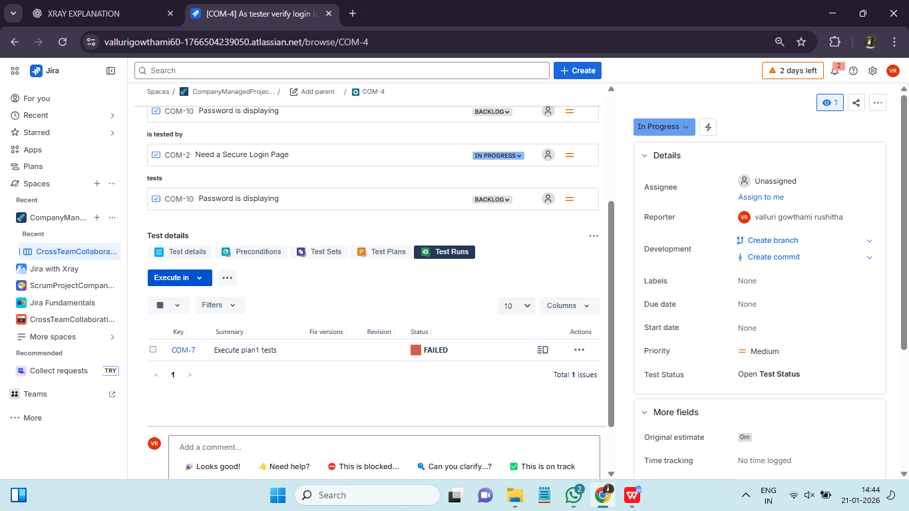

Executing Tests: Pass, Fail, Blocked, execution best practices ::
Once tests are added, execution begins.
Execution Status Options:
- Pass: Test executed successfully
- Fail: Test failed due to defect
- Blocked: Test cannot be executed due to dependency or issue
Testers update the status directly in Xray, ensuring real-time visibility.
Execution Best Practices :
To ensure accurate and reliable results:
- Execute tests in the defined order
- Follow test steps carefully
- Record results immediately
- Add clear comments for failures
Consistent execution practices improve data quality and reporting accuracy.

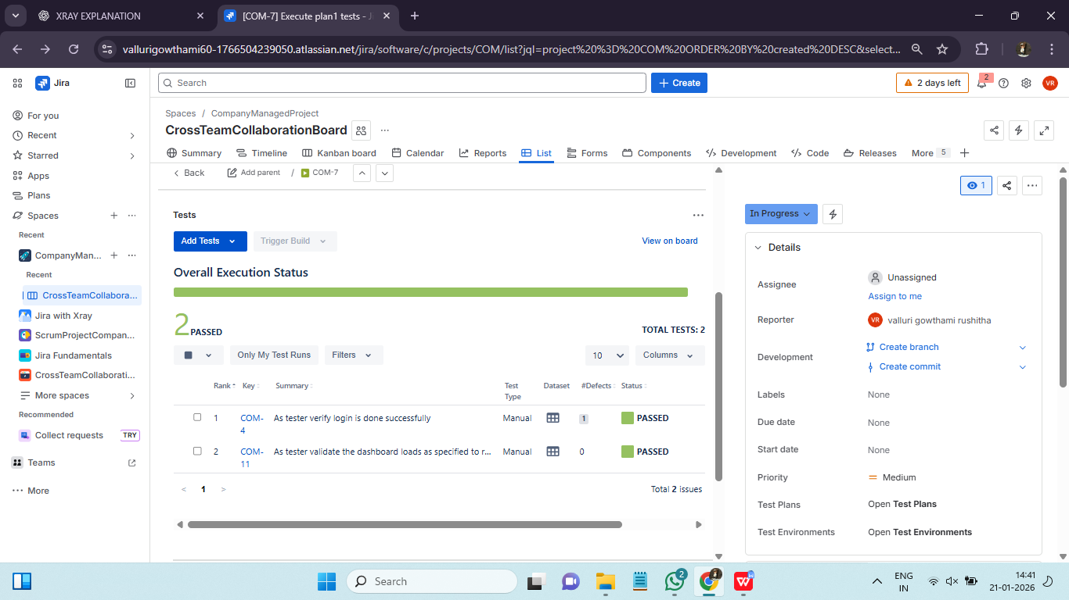

Evidence Management: Screenshots, logs, evidence standards ::
Evidence provides proof of test execution and is critical for audits and defect analysis.
Types of Evidence:
- Screenshots
- Log files
- Videos
- Error messages
Xray allows attaching evidence at the test execution level, ensuring all artifacts are centrally stored
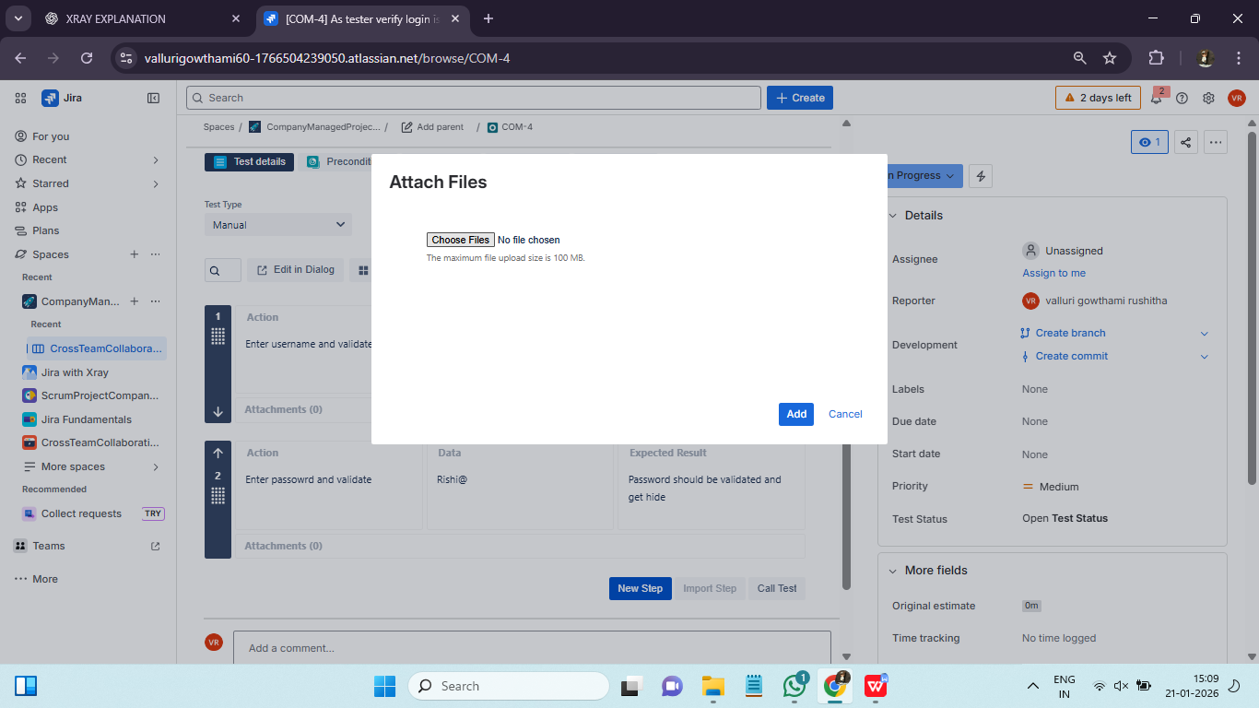

Evidence Standards and Guidelines :
Organizations often define standards for evidence collection:
- Mandatory screenshots for failures
- Clear naming conventions
- Environment details included
Following standards ensures consistency and compliance.

Defect Flow: Create bugs, link defects, retesting, execution history ::
When a test fails, a defect is logged and linked to the test execution.
Defect Flow Steps:
- Identify failure
- Create Bug issue in Jira
- Link bug to failed test
- Assign to developer
This linkage ensures traceability and faster resolution.
Linking Defects to Test Executions :
Linking defects to test executions allows teams to:
- Track impact of defects
- Analyze failure patterns
- Ensure defects are retested after fixes
This linkage is crucial for quality reporting.
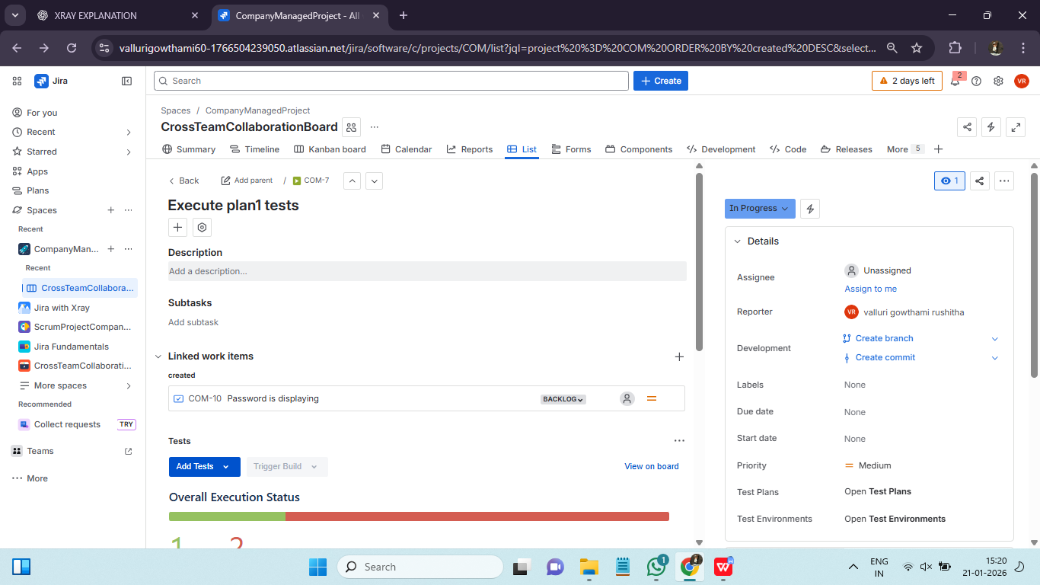
Retesting and Re-execution:
After a defect is fixed, the associated test is re-executed.
Re-execution Process:
- Verify fix availability
- Re-run the failed test
- Update execution status
- Add new evidence if required
Re-execution ensures that fixes are validated before release.

Execution History and Audit Trail
Xray maintains execution history, showing:
- Who executed the test
- When it was executed
- Result changes over time
This audit trail is valuable for compliance and root cause analysis.
